2-Selenium

findElement(locator) this method is used to find the WebElement.
Locator is defined by ‘By’ class and it’s method name depending upon whether to find name or classname or tagname or id etc.,

findElements(locator) this method is used to find multiple Webelements.

Basic Locators:
id, name, linkText, partialLinkText used to locate specific element
tagName, className used to locate group of elements

Customized locators:
CSS Selector
Xpath

1)By.name()
WebElement nameBox=driver.findElement(By.name("enter-name"));
nameBox.sendKeys("Tanya Coder"); //sendKeys() for entering text

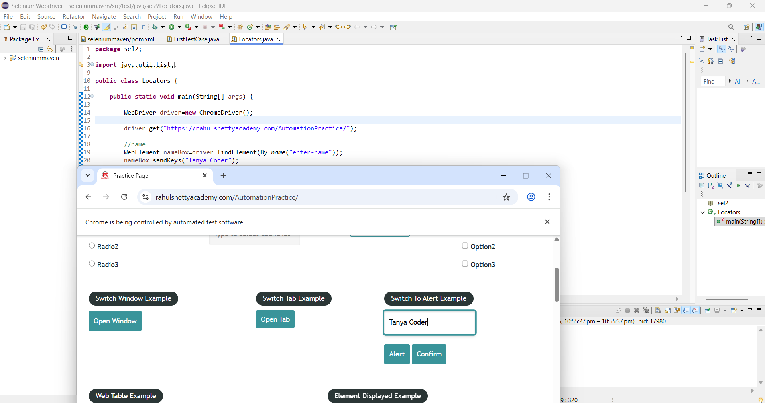

2)By.id()
WebElement countryBox=driver.findElement(By.id("autocomplete"));
boolean status=countryBox.isDisplayed(); //isDisplayed() to check whther the element is being displayed or not
System.out.println("Display status:"+ status);

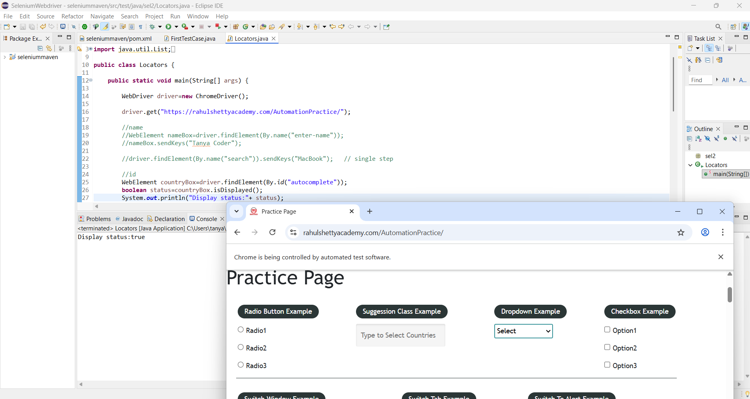

3) By.linkText()
driver.findElement(By.linkText("REST API")).click(); //click() to click

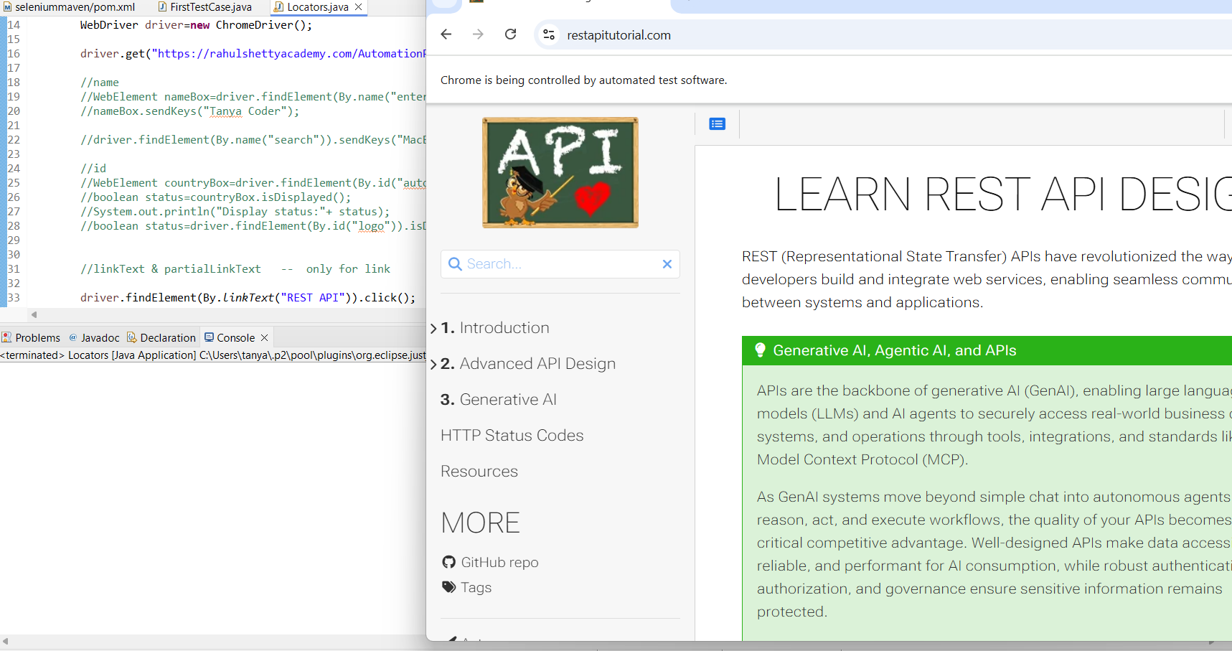

4) By.partialLinkText()
driver.findElement(By.partialLinkText("API")).click();

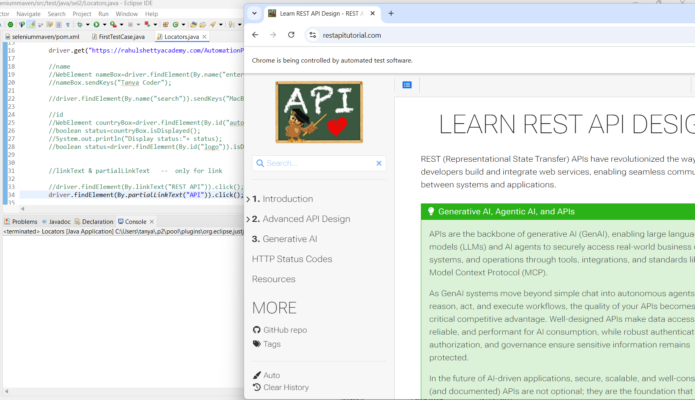

5) By.className()
List<WebElement> footerLinks=driver.findElements(By.className("gf-li"));
System.out.println(footerLinks.size());
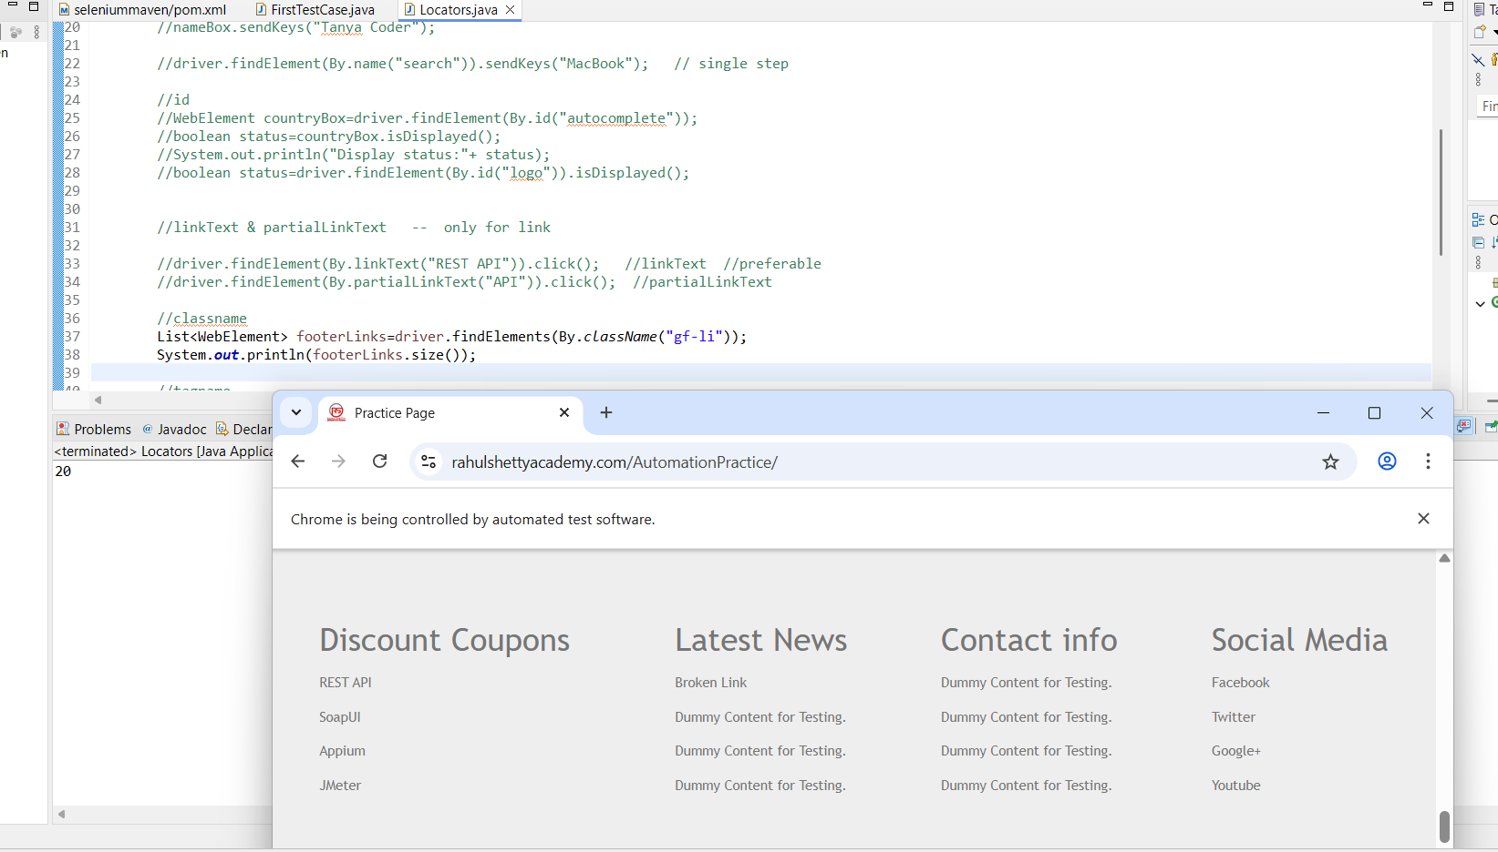

6) By.tagName()

List<WebElement> links=driver.findElements(By.tagName("a"));
System.out.println("Links count:"+links.size());

List<WebElement> images=driver.findElements(By.tagName("img"));
System.out.println("Images count:"+images.size());

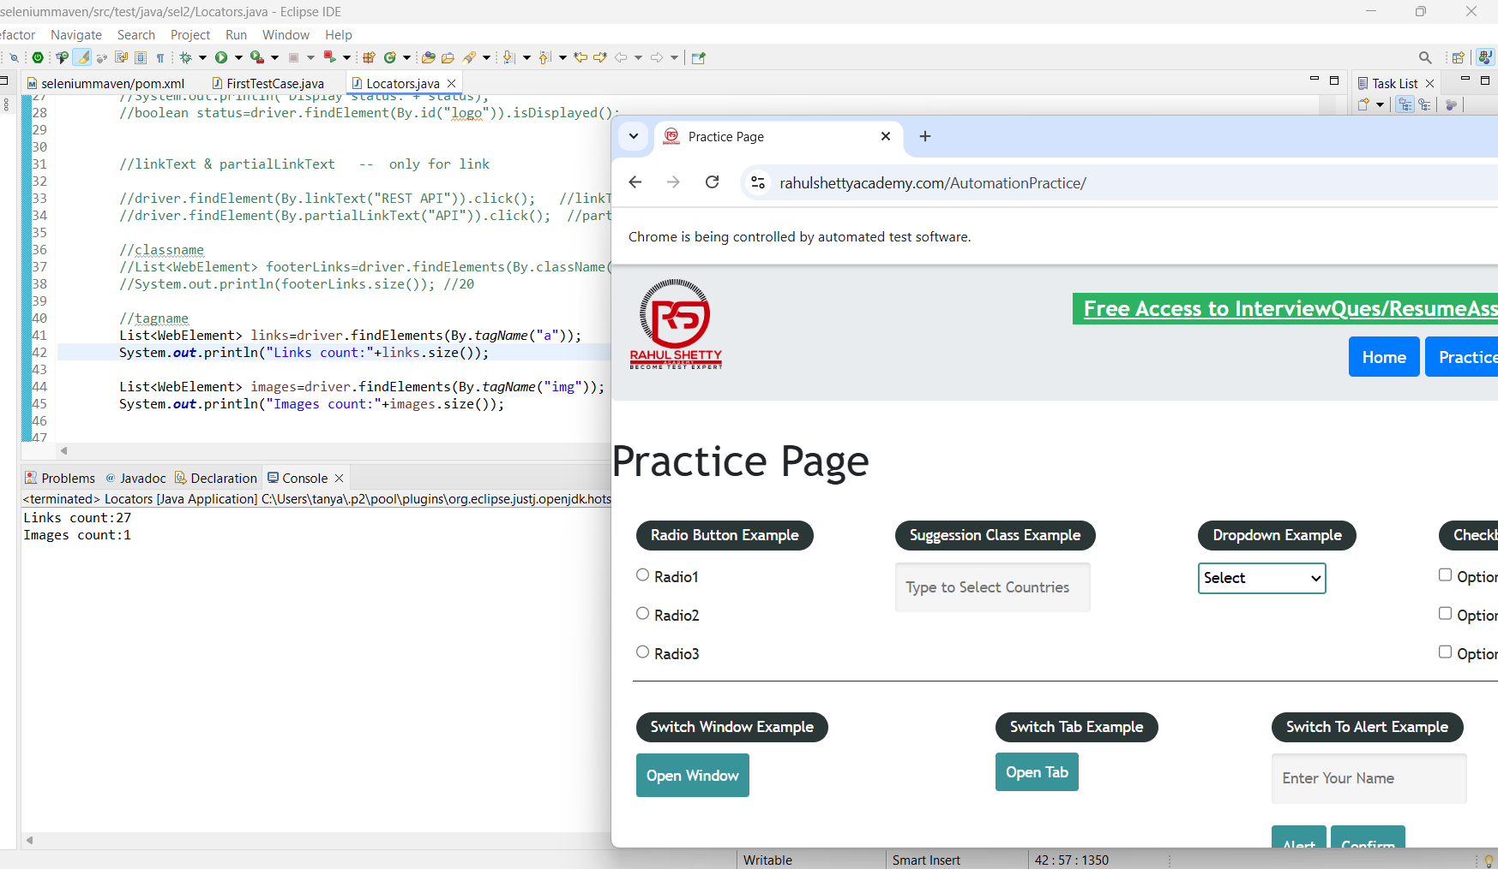

7) NoSuchElementException When element not found using findElement()

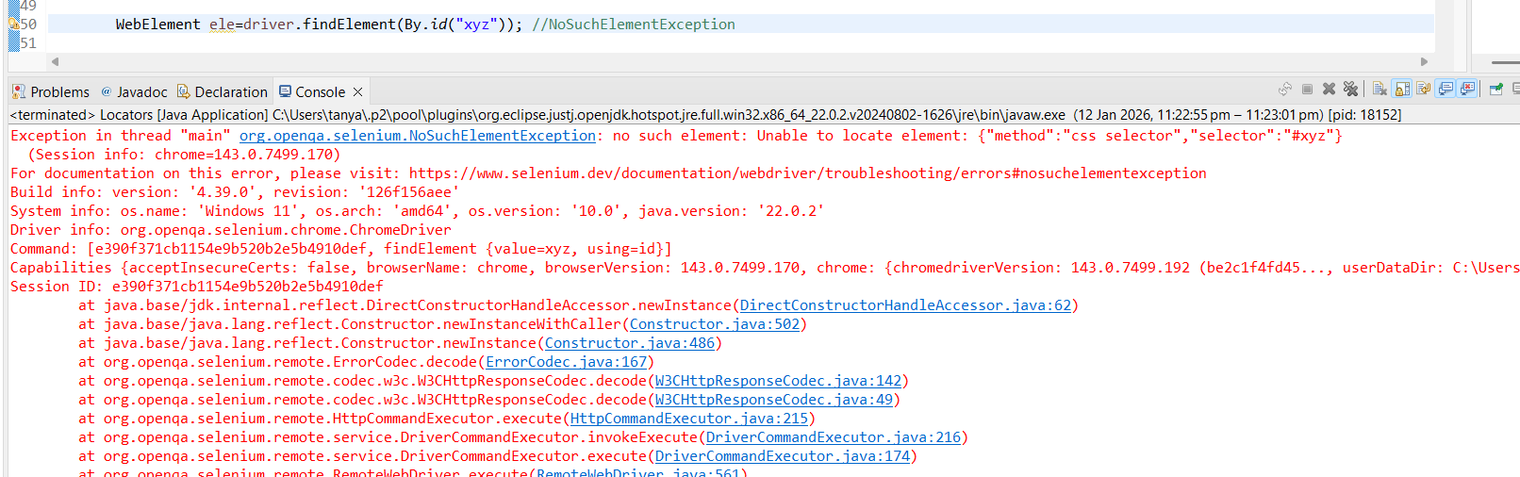

Note: No exception raises when used findElements()
If used .size() then returns 0.

